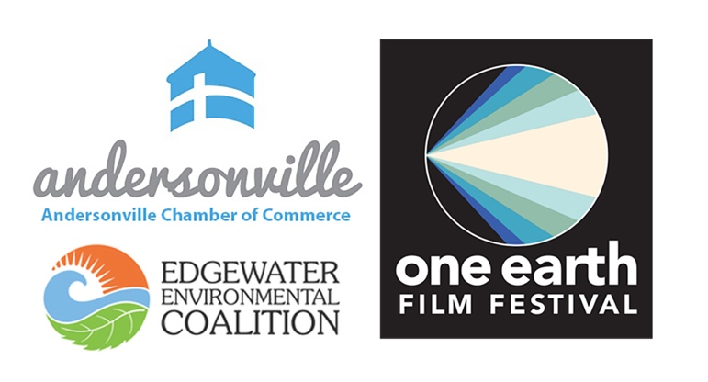
FOR IMMEDIATE RELEASE

PRESS CONTACT: David Rosenberg
David Rosenberg Public Relations
(773) 505-1429 | david@drpublicrelations.com

CLICK HERE to download publicity images.

Andersonville Chamber of Commerce & Edgewater
Environmental Commission Host In-Person Screening of
“Plastic Bag Store: The Film”
Friday, March 11 at Philadelphia Church

Part of the 11th annual One Earth Film Festival
CHICAGO (February 23, 2022) – The Andersonville Chamber of Commerce (ACC) and Edgewater Environmental Coalition (EEC) are pleased to co-host an in-person screening and discussion of “Plastic Bag Store: The Film,” part of the 11th annual One Earth Film Festival. This thoughtfully creative film exploring the future impact of plastic waste will be screened Friday, March 11 at 5:30 pm at Philadelphia Church, 5437 N. Clark St. in Andersonville. Tickets ($8 suggested donation) are available at oneearthfilmfest.org. Recommended for ages 12⁺.

“Plastic Bag Store: The Film,” by Robin Frohardt is dynamic series of stories that traverse ancient history, the present day, and a future dystopia, employing inventive puppetry, humor and craft to explore how the plastic waste we leave behind today might be misinterpreted by future generations. View the trailer here. The feature film will be preceded by the stop-motion, 1.5-minute film “Plastic Ecosystem” by Stefie Gan, an Official Selection from the One Earth Young Filmmakers Contest.

Comments Andersonville Chamber of Commerce Director of Business Services and District Manager
David Oakes, “We are thrilled to be able to take part in the One Earth Film Festival and showcase an incredible film that highlights a very serious problem that touches all of us. We actively reflect the environmentally conscious ethos of Andersonville by spearheading initiatives like Clark Street Composts with WasteNot Compost, Single Use Plastic Drives and planting educational Native Planter along SSA 22.”

The 11th annual One Earth Film Festival runs from March 4 – 13, 2022, featuring 17 thoughtfully curated film events that will be streamed online, with a number of in-person screenings at Chicago-based venues. For this year’s theme, the Festival chose “Turn The Tide” to highlight the urgency of the global climate crisis and the need for individuals and communities far and wide to take action on changing the planet’s catastrophic course. All One Earth presentations are designed to educate, inspire and prompt action amid current environmental catastrophes. For a complete listing of this year’s films, program information and tickets, visit oneearthfilmfest.org.

This program is partially supported by a grant from the Illinois Arts Council Agency.

One Earth Film Festival is the Midwest’s premier environmental film festival, creating opportunities for understanding climate change, sustainability and the power of people. It showcases top-issue, thought-provoking environmental films, leads audiences in interactive post-film discussions focused on solutions, and offers concrete actions people can take. One Earth Film Festival is a production of One Earth Collective.

The Andersonville Chamber of Commerce fosters a vibrant environment in which Andersonville businesses can thrive by attracting a diverse customer base; providing business support services and advocacy; and engaging in business attraction, long-range planning, and economic development.
The Edgewater Environmental Commission is a coalition of community members and environmental stewards. Bringing a green voice to local challenges, we empower people to build and maintain a more sustainable future through action, organizing, education, and advocacy. We are rooted in advancing a healthy and verdant Edgewater

###

